**Pandas**

**What is Pandas?**

* Pandas is a Python library used for working with data sets
* Pandas is a **powerful library** for **data analysis and manipulation** in Python. It provides **DataFrames** and **Series**, which make handling structured data easy.
* It has functions for analyzing, cleaning, exploring, and manipulating data.
* The name "Pandas" has a reference to both "Panel Data", and "Python Data Analysis" and was created by Wes McKinney in 2008.

**Installation of pandas:**

To install pandas, follow these steps based on your setup:

**1. Using pip (Recommended)**

If you have Python installed, you can install pandas using pip:

**pip install pandas**

If you need to upgrade pandas, use:

**pip install --upgrade pandas**

**Verifying Installation**

After installation, check if pandas is installed by running:

import pandas as pd

print(pd.__version__)

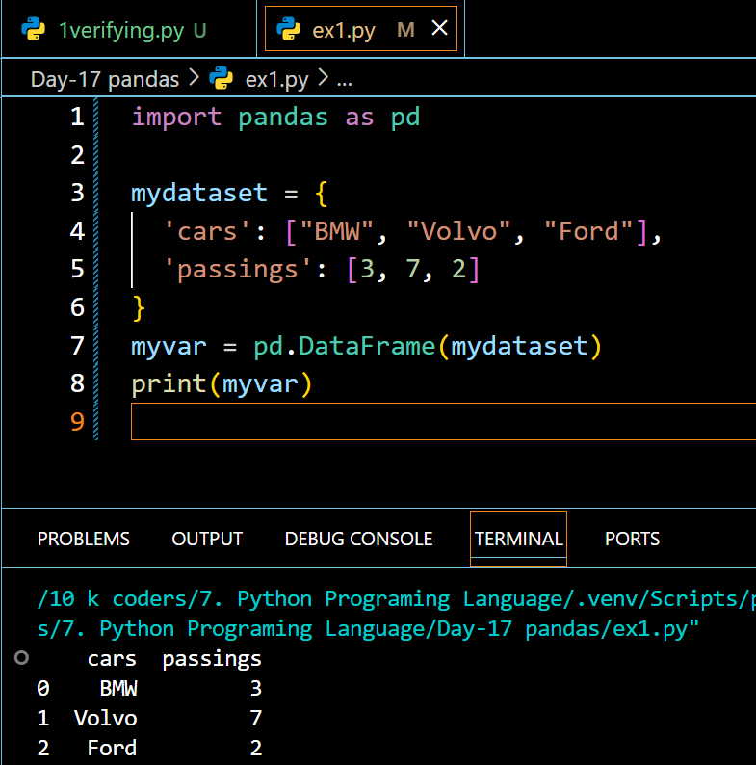

**Pandas Series**

**What is a Series?**

A Pandas Series is like a column in a table.

It is a one-dimensional array holding data of any type.

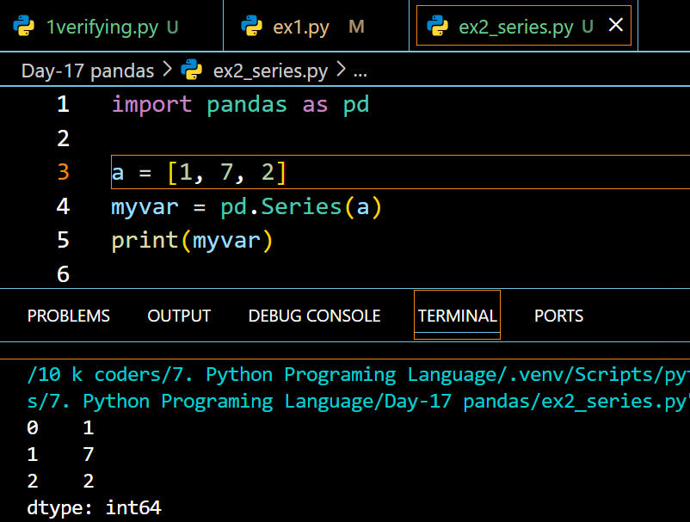

**Labels**

If nothing else is specified, the values are labeled with their index number. First value has index 0, second value has index 1 etc.

This label can be used to access a specified value.

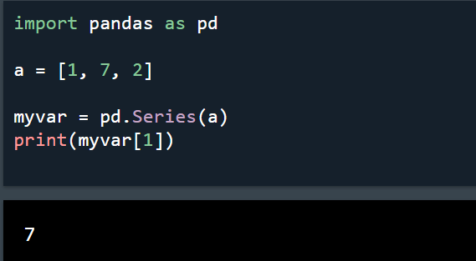

**Create Labels**

With the index argument, you can name your own labels.

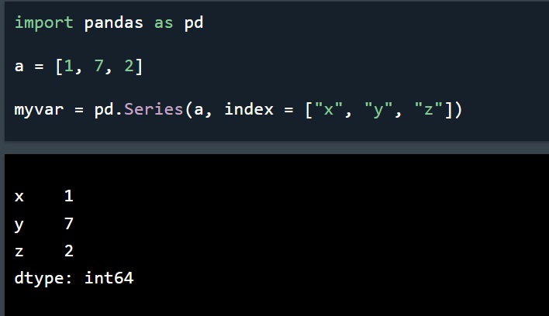

**Key/Value Objects as Series**

You can also use a key/value object, like a dictionary, when creating a Series.

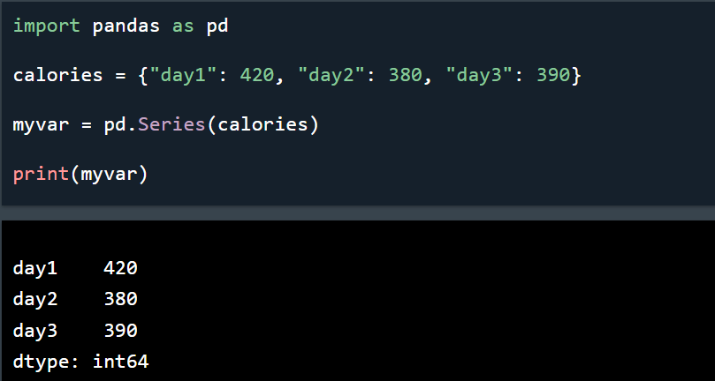

To select only some of the items in the dictionary, use the index argument and specify only the items you want to include in the Series.

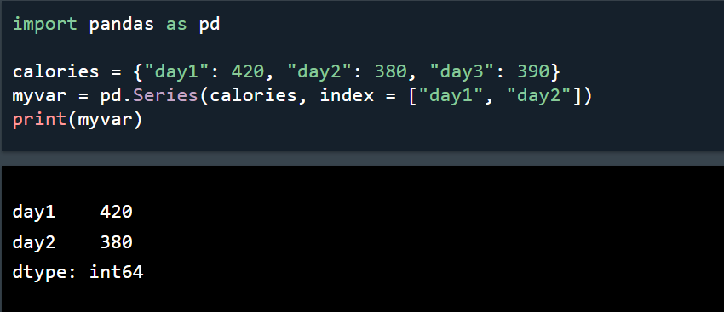

**DataFrames**

A Pandas DataFrame is a 2 dimensional data structure, like a 2 dimensional array, or a table with rows and columns.

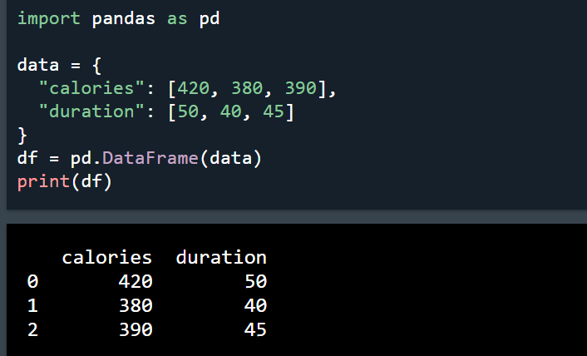

**Locate Row**

As you can see from the result above, the DataFrame is like a table with rows and columns.

Pandas use the loc attribute to return one or more specified row(s)

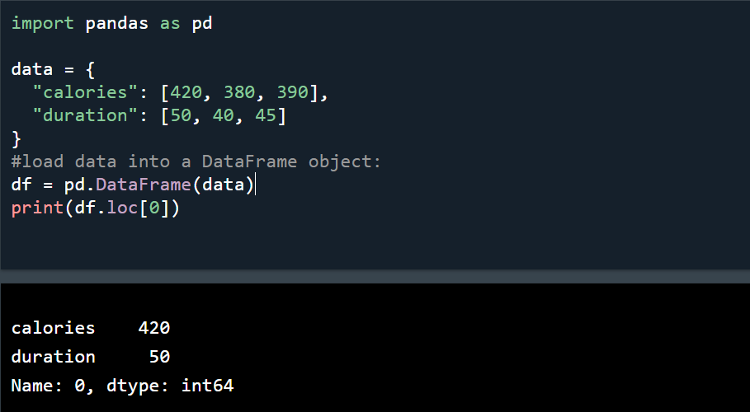

**Example**

Return row 0 and 1:

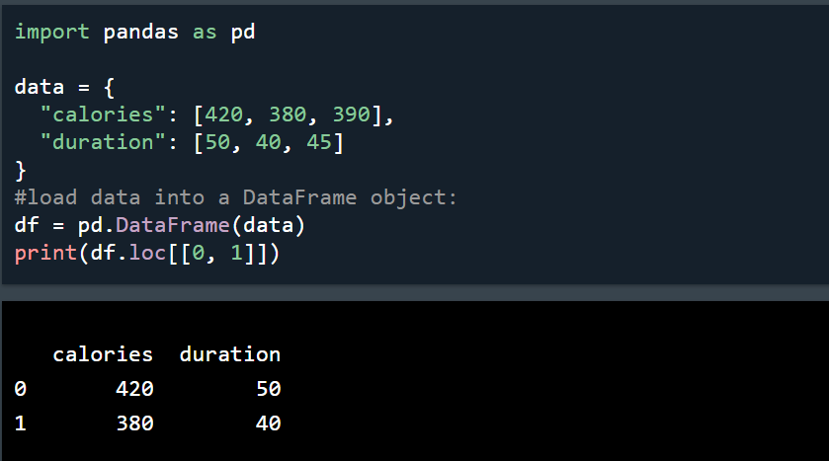

**Named Indexes**

With the index argument, you can name your own indexes.

**Example**

Add a list of names to give each row a name:

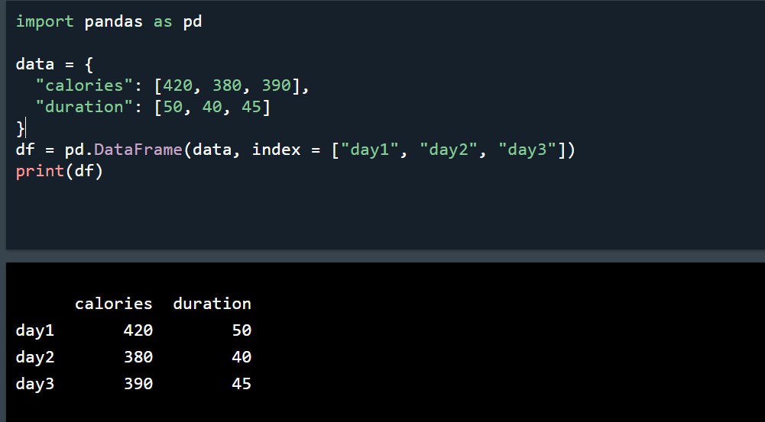

**Locate Named Indexes**

Use the named index in the loc attribute to return the specified row(s).

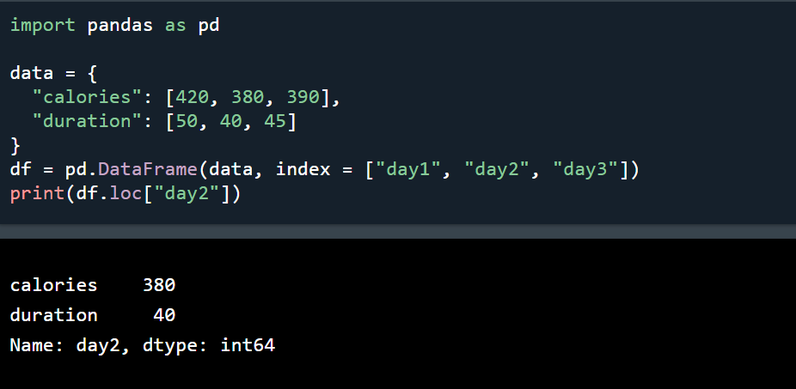

**Read CSV Files**

* A simple way to store big data sets is to use CSV files (comma separated files).
* CSV files contains plain text and is a well know format that can be read by everyone including Pandas.
* In our examples we will be using a CSV file called 'data.csv'.
* [Download data.csv](https://www.w3schools.com/python/pandas/data.csv). or [Open data.csv](https://www.w3schools.com/python/pandas/data.csv.txt).

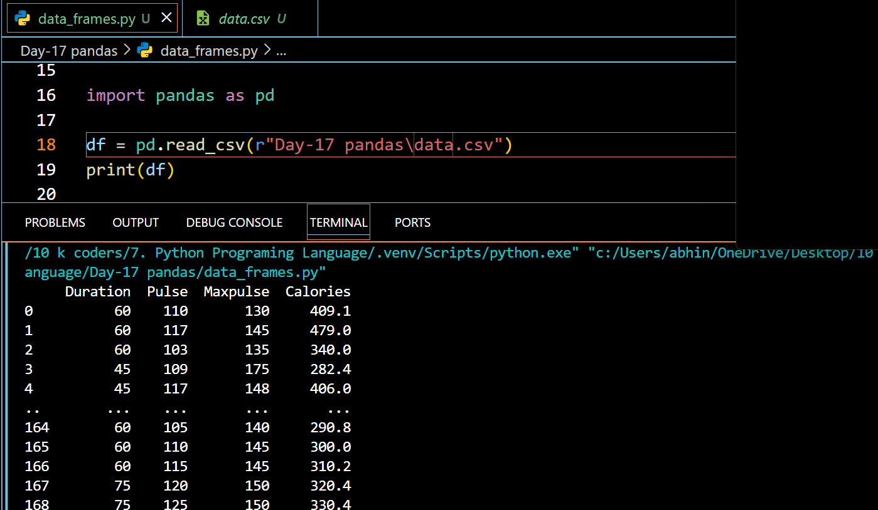

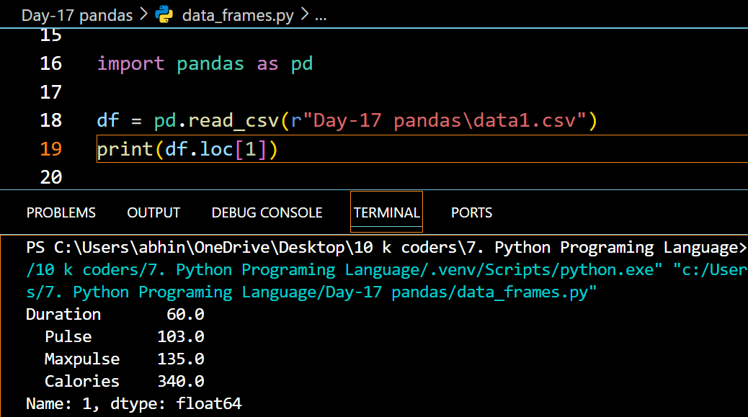

**Tip:** use to_string() to print the entire DataFrame.

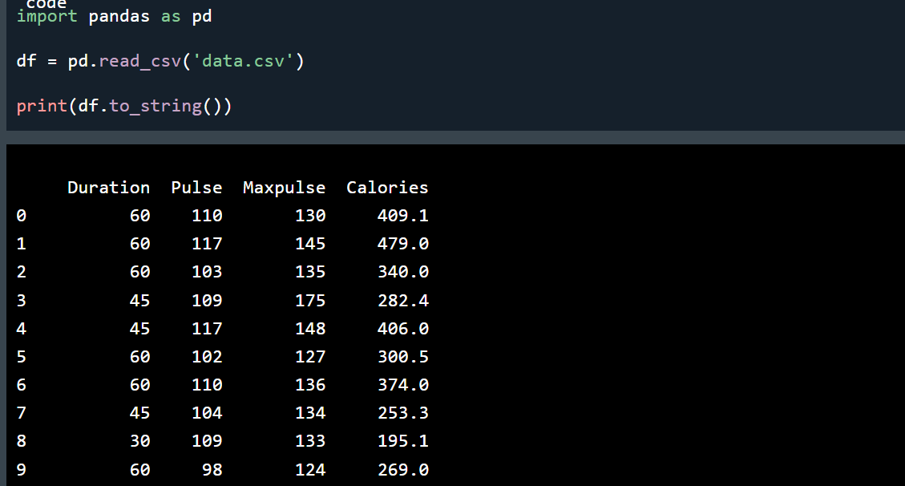

**Read JSON**

Big data sets are often stored, or extracted as JSON.

JSON is plain text, but has the format of an object, and is well known in the world of programming, including Pandas.

In our examples we will be using a JSON file called 'data.json'

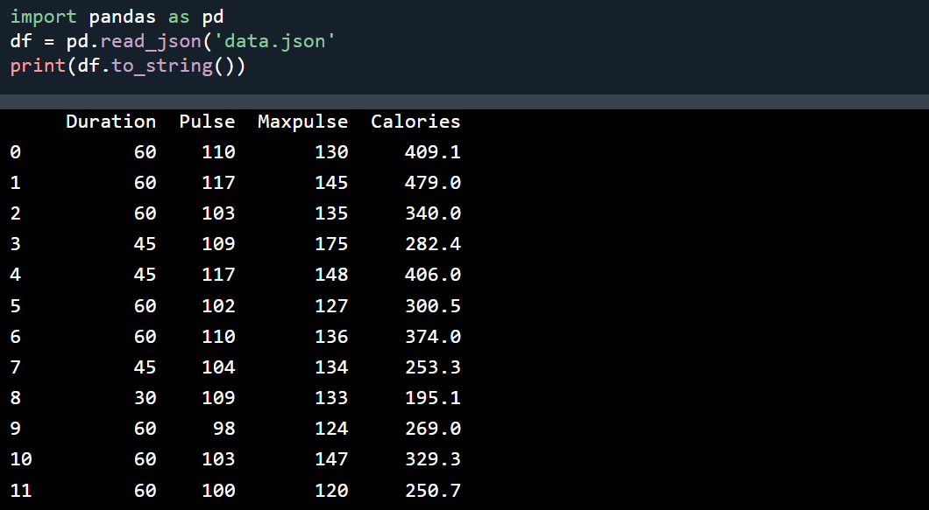

**Basic Methods:**

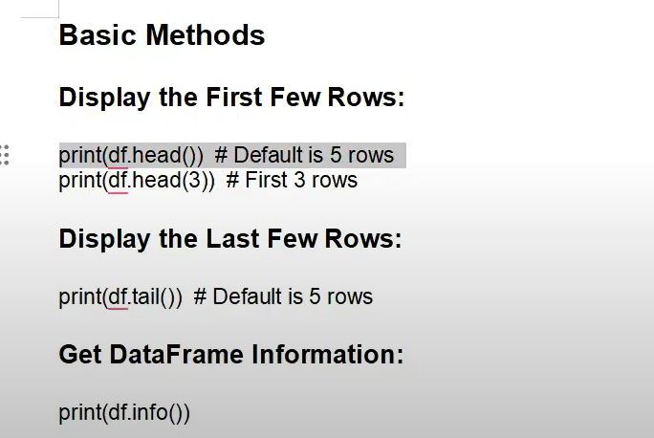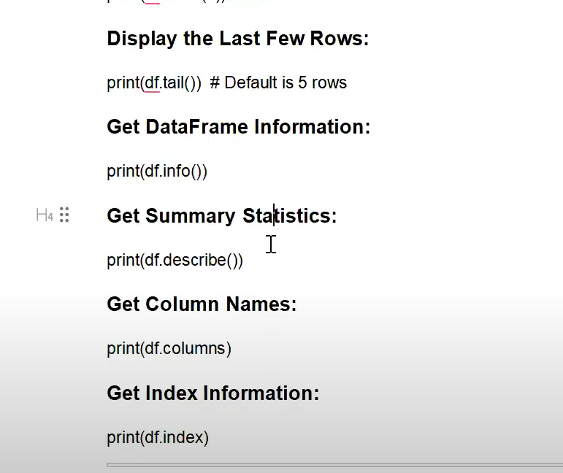

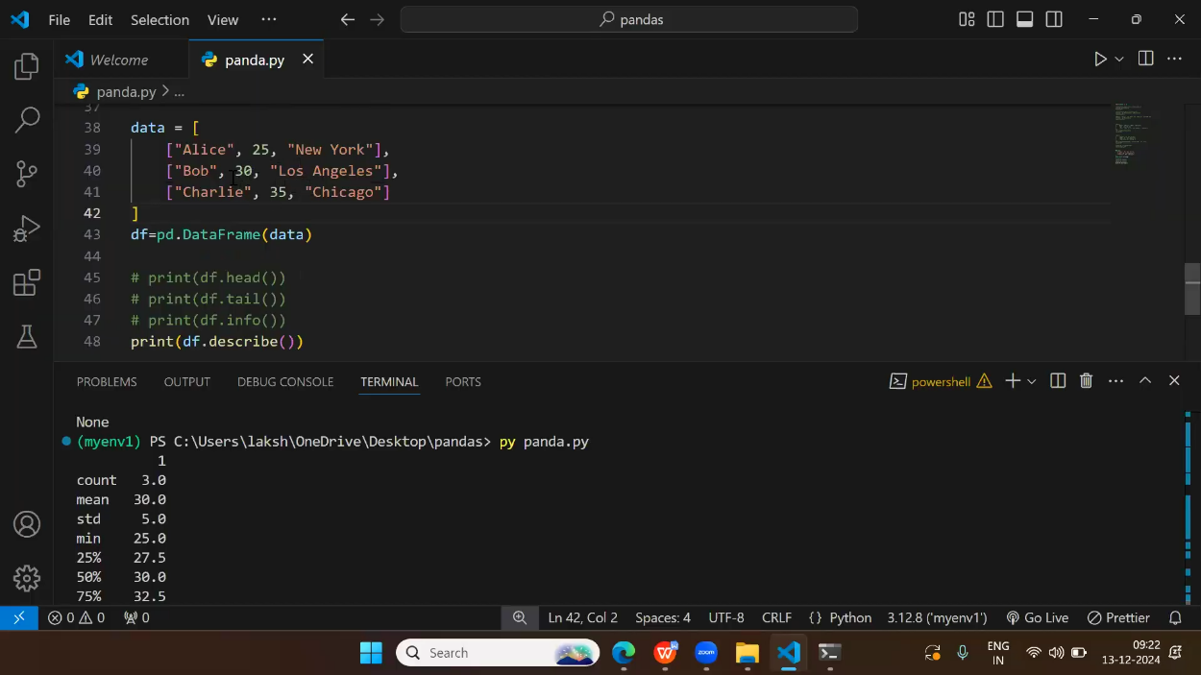

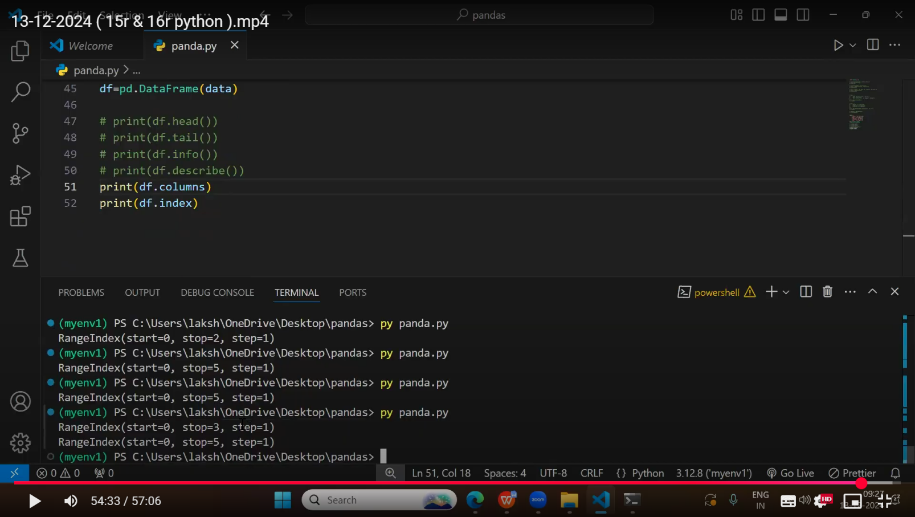

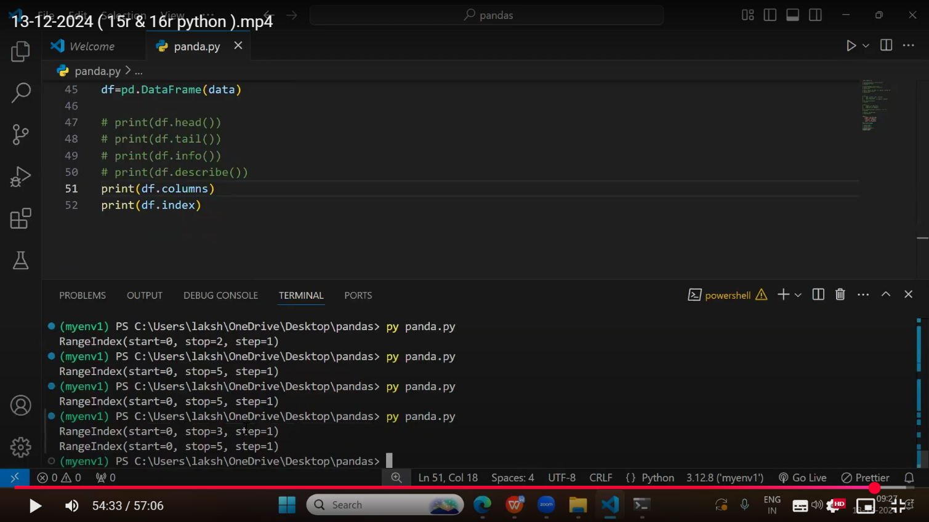

**Selecting methods**

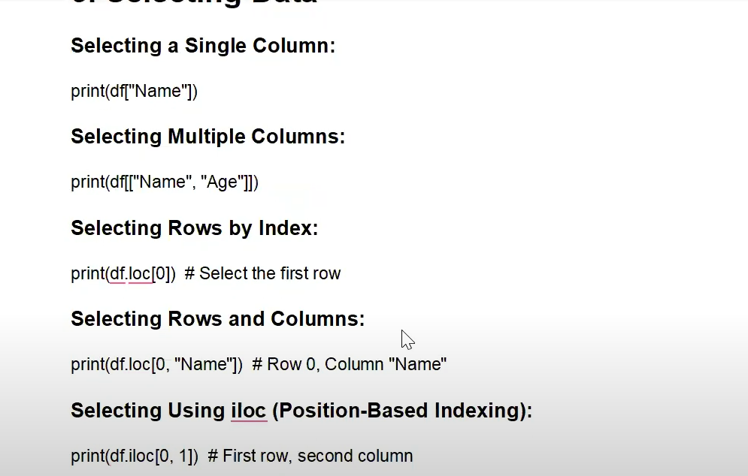

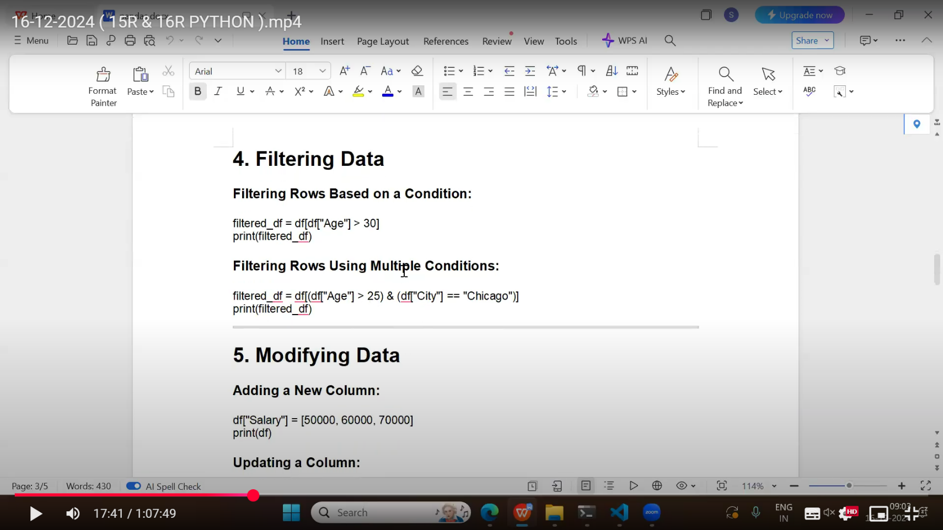

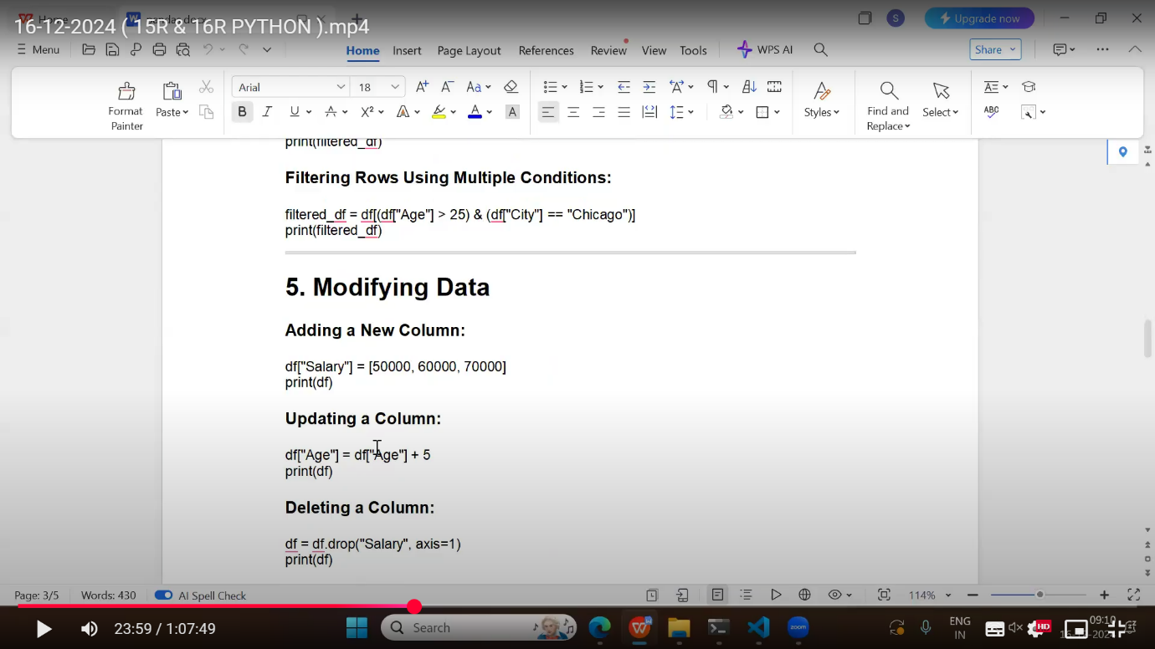

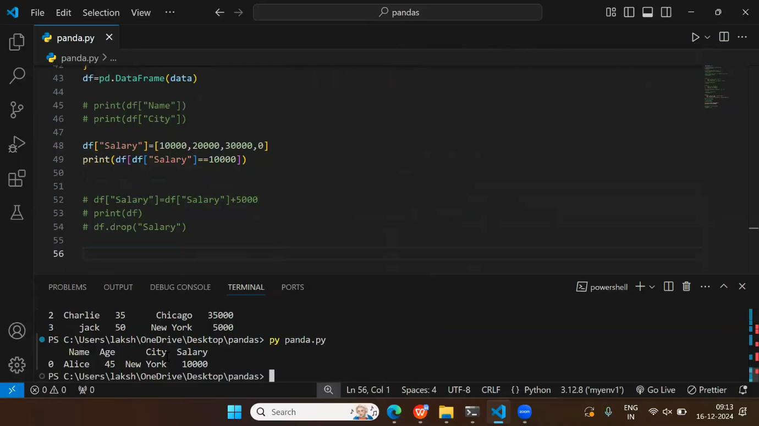



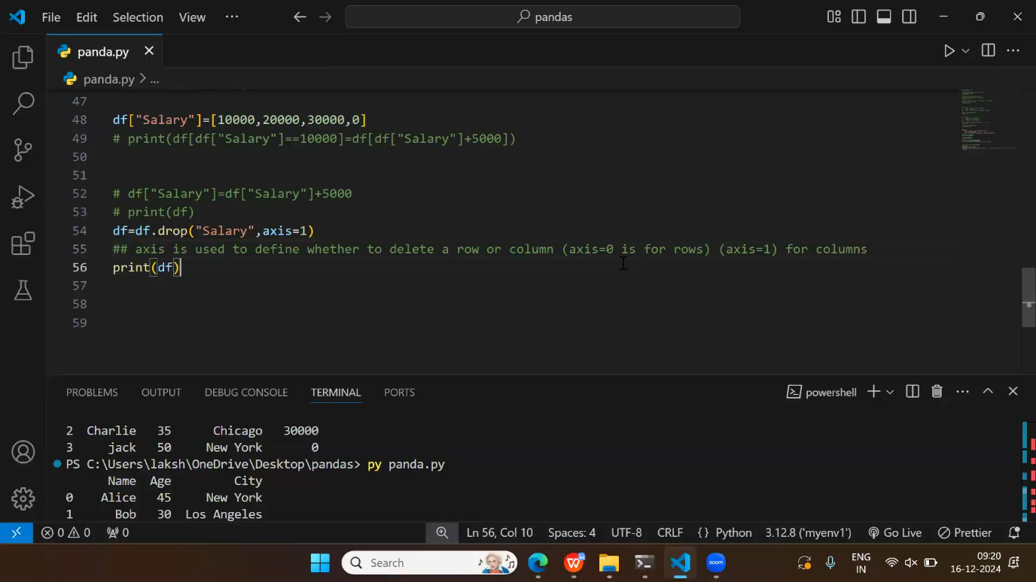

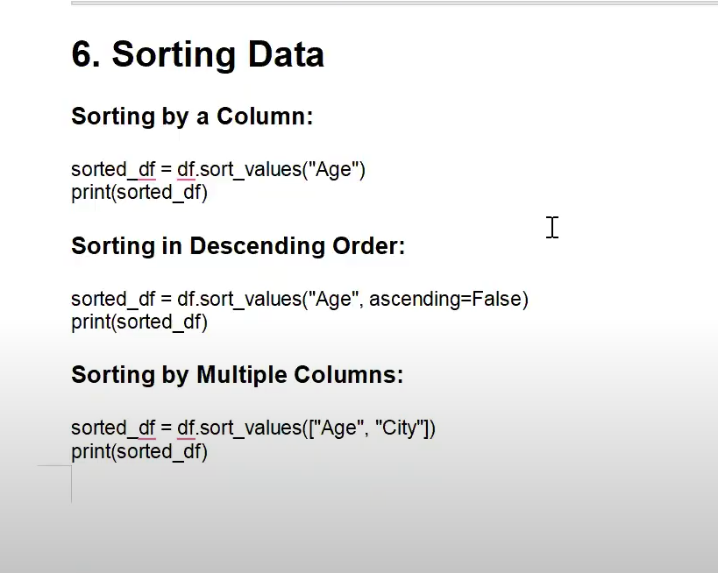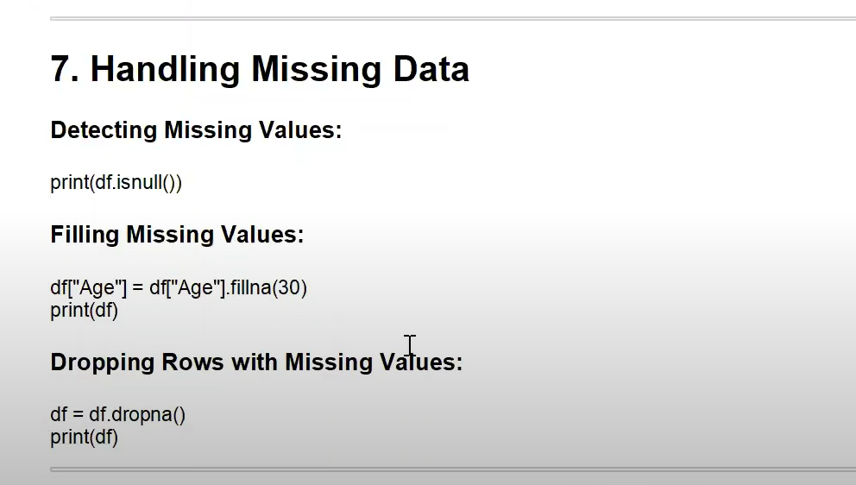

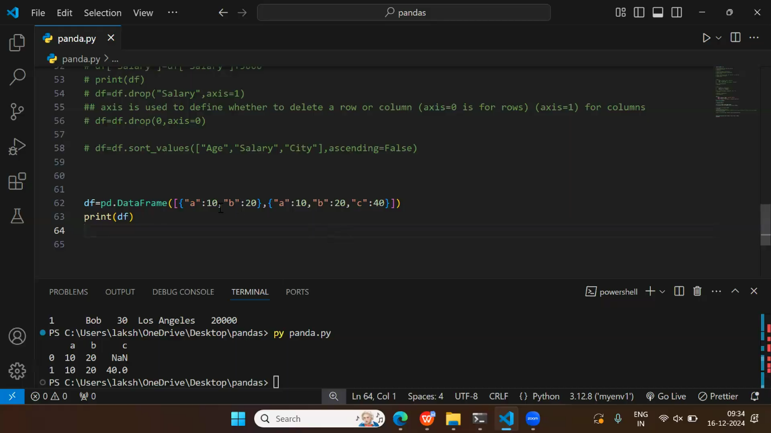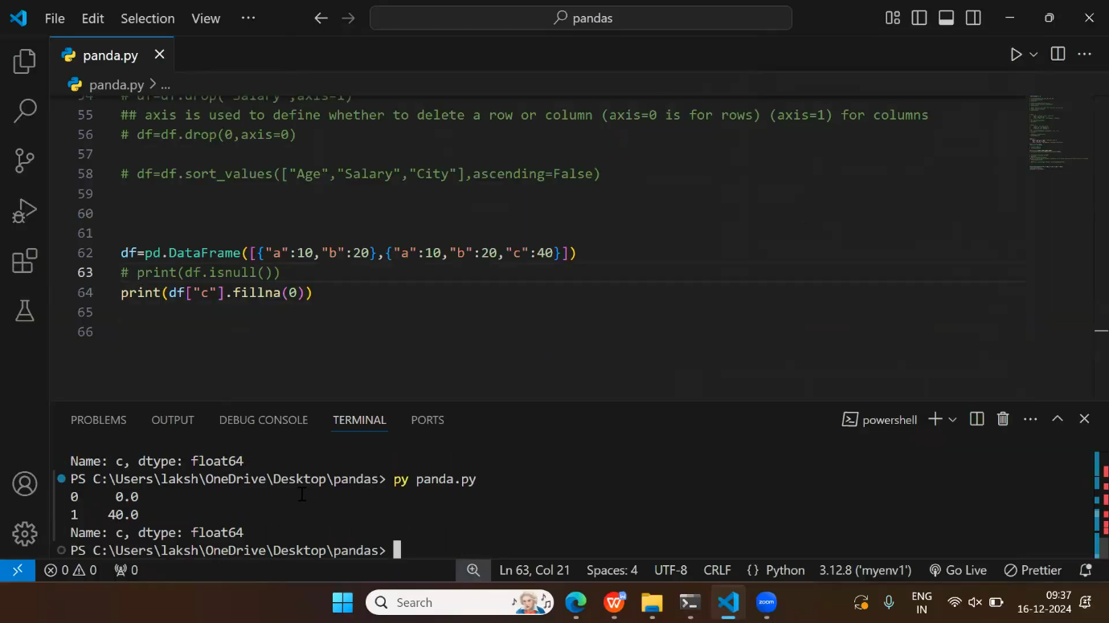

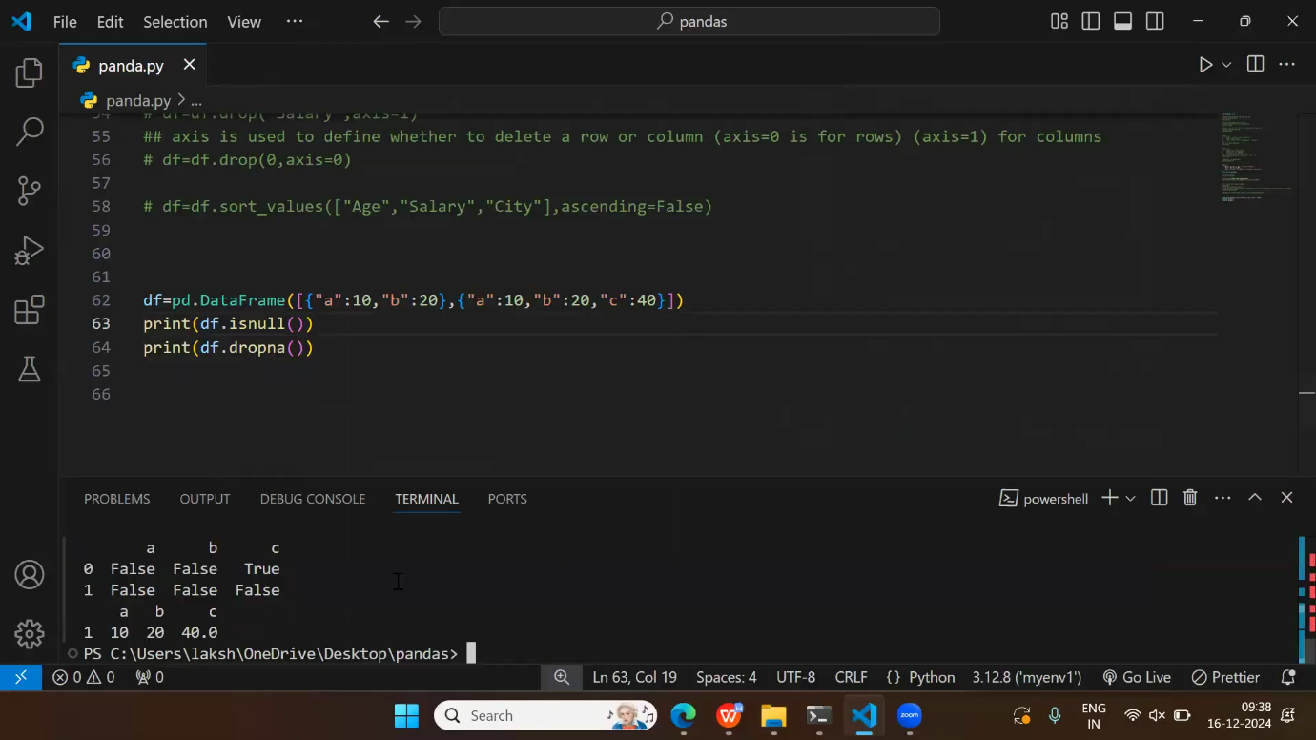

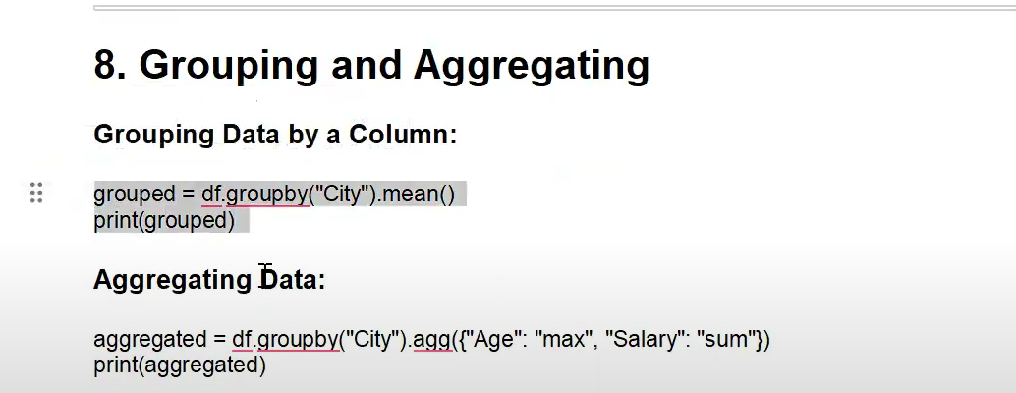

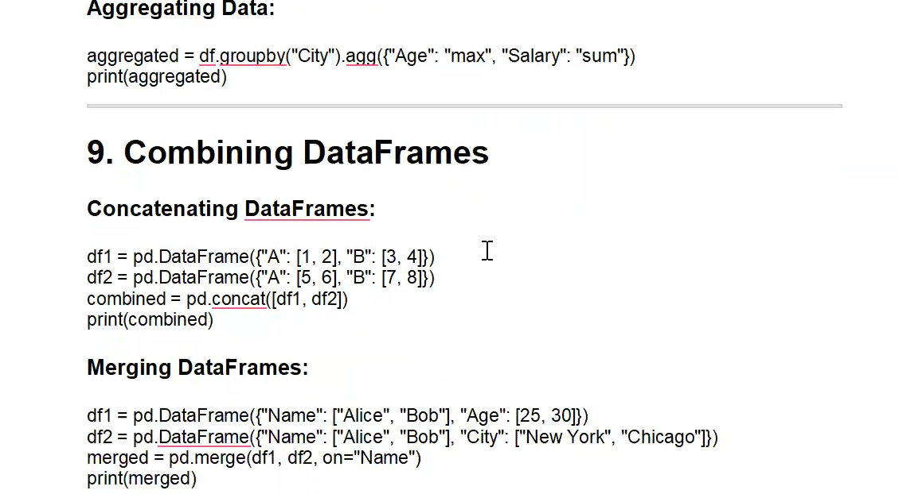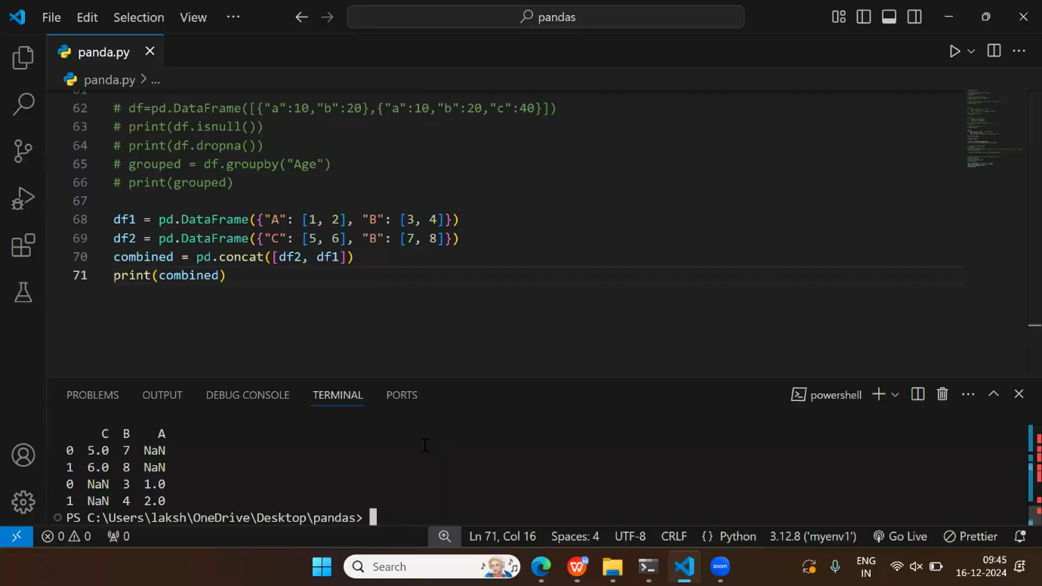

**Writing to a CSV file:**

df.to_csv(‘output.csv’, index=False)

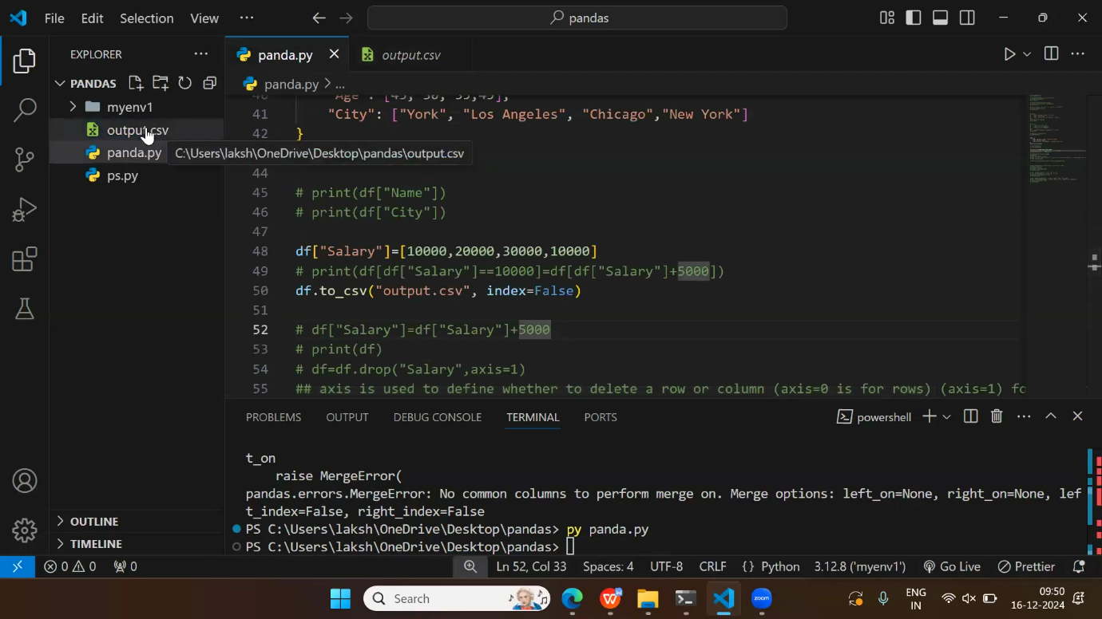

**Removing Duplicates**

To discover duplicates, we can use the duplicated() method.

The duplicated() method returns a Boolean values for each row:

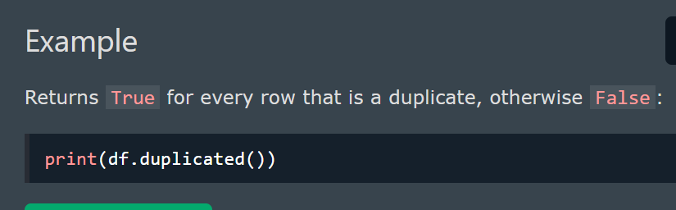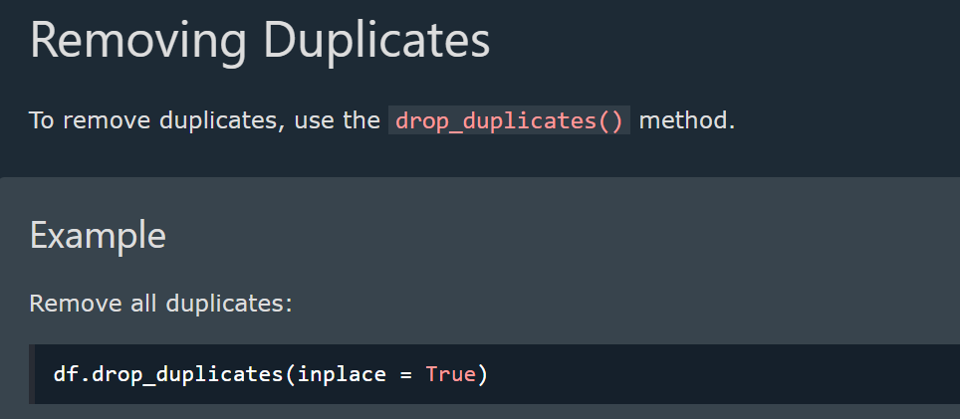

**Pandas - Data Correlations**

Finding Relationships

A great aspect of the Pandas module is the corr() method.

The corr() method calculates the relationship between each column in your data set.

The examples in this page uses a CSV file called: 'data.csv'.

[Download data.csv](https://www.w3schools.com/python/pandas/data.csv). or [Open data.csv](https://www.w3schools.com/python/pandas/data.csv.txt)

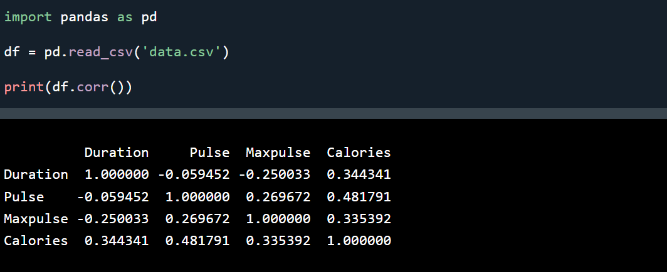

**Result Explained**

* The Result of the corr() method is a table with a lot of numbers that represents how well the relationship is between two columns.
* The number varies from -1 to 1.
* 1 means that there is a 1 to 1 relationship (a perfect correlation), and for this data set, each time a value went up in the first column, the other one went up as well.
* 0.9 is also a good relationship, and if you increase one value, the other will probably increase as well.
* -0.9 would be just as good relationship as 0.9, but if you increase one value, the other will probably go down.
* 0.2 means NOT a good relationship, meaning that if one value goes up does not mean that the other will.

**Plotting**

* Pandas uses the plot() method to create diagrams.
* We can use Pyplot, a submodule of the Matplotlib library to visualize the diagram on the screen.
* Read more about [ploting](https://www.w3schools.com/python/pandas/pandas_plotting.asp)